Modulprüfung: BBio119, Neurowissenschaften und Verhaltensbiologie
2. Klausur zur Vorlesung: Theoretische Neurowissenschaften.
SoSe 2017

Last name ____________________________________________________
First name ____________________________________________________
Matriculation No. ____________________________________________________

Notes:
- You have to perform the test without any auxiliary means or other persons.
- Fill your answers correctly into the given boxes or, if required, into the figures.
- Note: Please read the text carefully!
- If there is any lack of clarity, please ask the supervisor.
- IMPORTANT!!! Please firstly answer the topics you know well. Do not expect to be able to complete all the tasks, the test is not designed that way!
- Side note: The questions stem from examples that were given in the lecture or from old tests. Some were slightly changed (thus, a bit of thinking should help – as always ☺). All in all, your lecturer hopes that this test is not too difficult for you. Good luck.

You can maximally score 60 points.

1) Topic: Introduction to Modeling (first lecture)

- What is a receptive field (choose skin or retina as an example)?  - What does orientation selectivity in the visual cortex mean?  - The diagram to the right shows a model of orientation selectivity. Please explain the model in words.  - The triangles and crosses denote projection neurons. In which brain structure are they located?  - Name the projection neurons (triangles and crosses) with the correct term for their stimulus sensitivity. (Hint: There are 2 correct solutions.)  - How many sub-fields are found in the receptive field shown in the diagram on the right? | 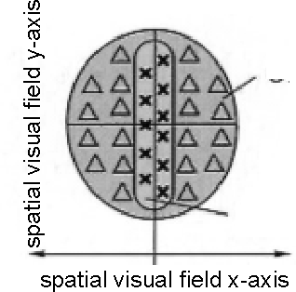  Fig. 1 Visual cortical receptive field

A) (2 points):

B) (2 points)

C) (2 points)

D) (0.5 points)

E) (1 point, please mark in the diagram, give only one solution!!!)
F) (0.5 points)
2) Topic: Calculating with Neurons

The following diagram shows a schema of a possible synaptic wiring. We assume that directly at the synapse, all postsynaptic potentials have the same (absolute) amplitude. The neuron resides in its resting potential. Please draw the resulting potential at the soma for the following cases: (draw clearly and, where necessary, shortly explain what you mean!)

(2 points per correct answer)

- Synapses A and B are excitatory. They are excited simultaneously. Their equilibrium potential is far away from the resting potential.
- Same as (1) but A is excited long before B.
- Same as (1) but B is excited before A such that both EPSPs reach the summation point at the same time.
- Same as (3) but the equilibrium potential of both synapses is only slightly above the resting potential.
- Synapse A is excitatory, synapse B is inhibitory. They are excited simultaneously. Their equilibrium potential is far from the resting potential.
- Same as (5) but the equilibrium potential of A is almost identical to the resting potential (Beware!).
7) Additional question: In the wiring diagram, indicate the approximate summation point where both PSPs are summed up for the first time.

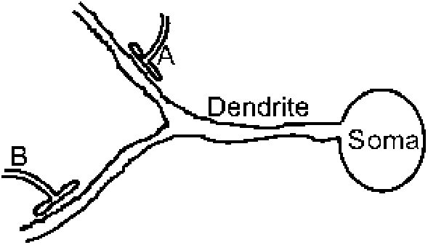  Fig 2) Schematic of a small neural circuit. | Question 1  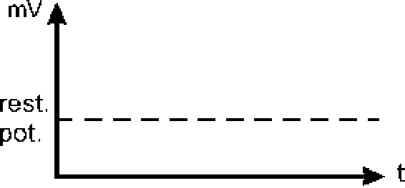
Question 2 | Question 3
Question 4 | Question 5
Question 6 | Question 7: Please express your answer in Fig. 2!

3) Topic: Calculating with Neurons (continued)

The equation below describes the normalized NMDA conductivity α. The diagram shows a plot of this equation.  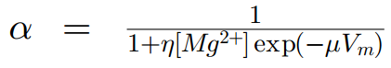  η = 0.33 mM⁻¹  μ = 0.06 mV⁻¹  [Mg2+] = 0.65 mM | 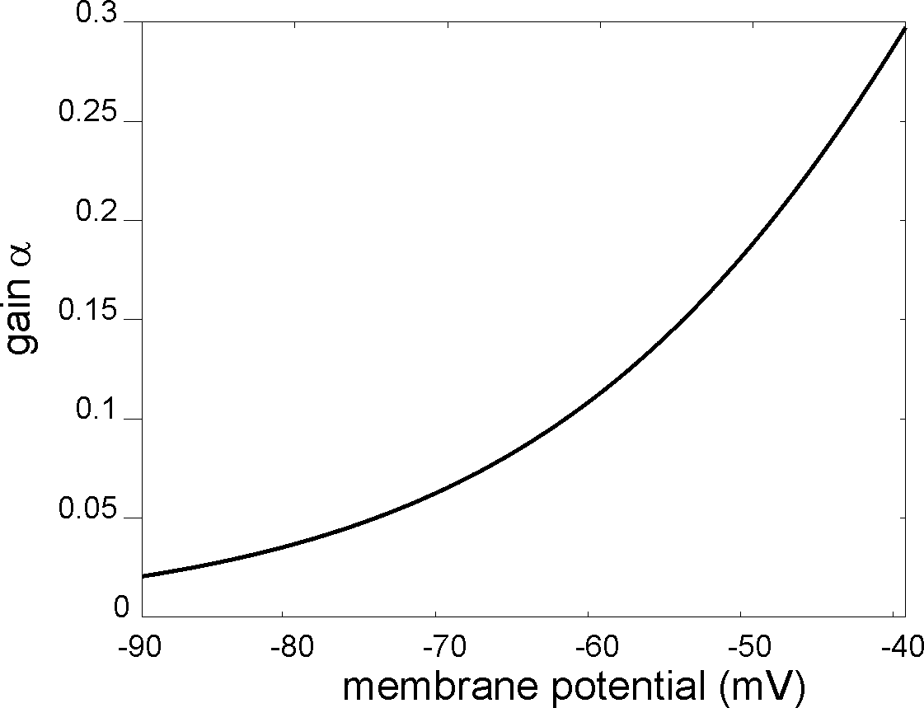  Fig. 3 NMDA characteristic

- We assume a resting potential of -70 mV. Which potential doubles the gain α, which potential triples it?
- State α for [Mg²⁺] very small, i.e., zero! State α for [Mg²⁺] very large, i.e., “infinite”!
- Which ions are transported through the NMDA channel?
- The NMDA channel is related to a multiplicative synaptic effect. Please elaborate how it works!
- Why does the depolarization of the cell membrane have to be continuous (long-lasting) for the NMDA channel to become active? Is this issue covered by the above equation?

A) (3 points)

Doubled: Quadrupled: (unit=?)
B) (2 points)
α₀ = | α∞ =
C) (0.5 points)
D) (4 points)

E) (2 points)

4) Topic: Learning

A)
- The formula below is used to calculate the “return“ R_{t} in Reinforcement Learning. What is the “return“?
- What is the quantity γ called?
- Let γ=0.9. If, at t+3, the reward r is 0.7, with which value does it contribute to the return R_{t} (all other rewards are zero!) ?

Answer to A): i) (2 points)

ii) (0.5 points)

iii) (1 point)

B)  i) Let again γ=0.9. Fill in the „Value Table“ V(s) given here for the 25 states s similar to what a temporal difference learning algorithm (TD-learning) would yield after convergence. The agent can perform the following four actions: North, East, West, South. (4 points)  (Hint: Think about how many steps the agent has to perform, starting from a given point, to get rewarded. This means, distal states are of less value. Somehow, you have to consider γ…..)  ii) If the agent could perform the additional action Northeast, which different approximate value would the state marked by x finally take?  Answer ii: (2 points) | 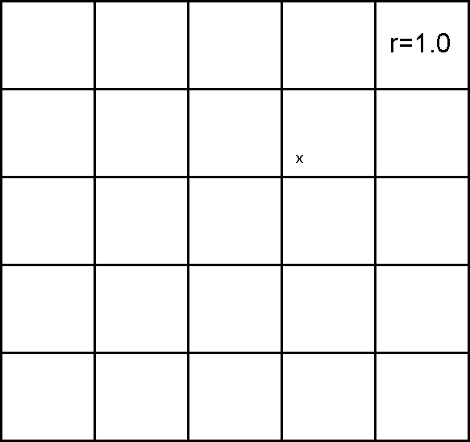  Fig. 4) Value table

5) Topic: Learning (continued)

In the lecture, we defined the Rescorla Wagner Rule with two inputs as follows:
We define: v = ω₁u₁ +ω₂u₂, with u_{1,2}=1 or =0, binary and
Rescorla Wagner Rule: ω_{i} → ω_{i} + μδu_{i} i=1,2 and with δ = r – v
C)
i) What is inhibitory conditioning?
ii) Explain using the Rescorla Wagner Rule, why the weight ω₂ (of u₂) becomes negative for inhibitory conditioning.

Answer to C): i) (2 points)

ii) (2 points)

B) Label the arrows in this diagram (please insert your answer directly into the diagram).  Describe the related experiments in words (insert answer here).  (4 points) | 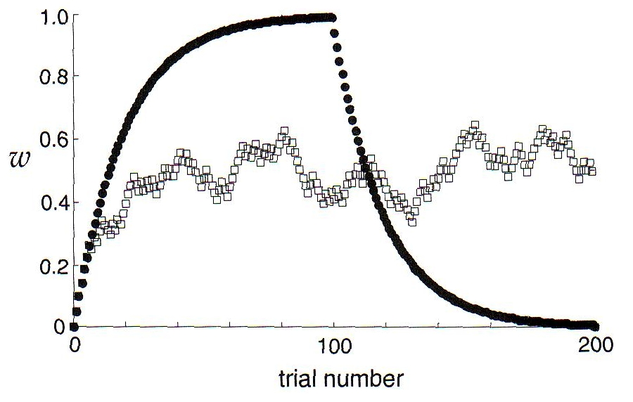  Fig. 5) Weight change curves following different types of conditioning experiments modeled with the Rescorla Wagner Rule

6) Topic: Maps in the Brain

- Which area of the retina is most prominently represented in the visual cortex (V1) (i.e., is represented with the highest number of neurons)?

- Name a part of the visual cortex that is mainly responsible for color vision.

Answer to A): (2.0 points)

Answer to B): (2.0 points)

- (4.0 points) If we understand the retina as a part of the complex number plane, we can express the transformation of retinal coordinates r to cortical coordinates by a complex logarithm: r=a+ib → log(r) = log(a+ib).
The following figure illustrates this transformation. On the left (retina), there are three solid lines: a circle (1) and two straight lines (2,3). Please indicate on the right the corresponding lines of these three lines in the cortex after the transformation (draw solid lines and mark).

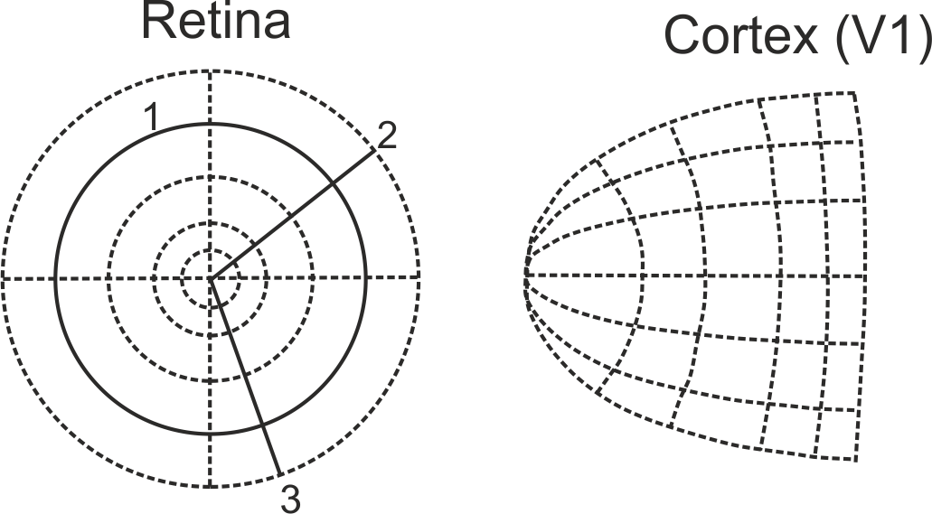

- In the left part of the figure, the whole circle 1 is solid. Why is this wrong, regarding the right part of the figure?

Answer to D): (1.0 point)

